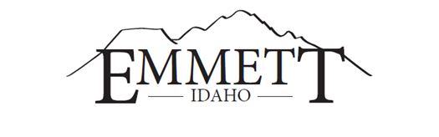
MAYOR:  Gordon W. Petrie, Presiding  CITY ATTORNEY:  Jake Sweeten  CITY CLERK:  Lyleen Jerome | EMMETT CITY COUNCIL  Live Stream  www.cityofemmett.org/meeting  Emmett City Council &  Gem County Commissioners  Joint Meeting  April 27, 2021  6:00 P.M. | COUNCILORS:  Steve Nebeker, President  Thomas Butler  Eltona Henderson  Gary Resinkin  Denise Sorenson  Michelle Welch  COMMISSIONERS:  Mark Rekow, Chairman  Bryan Elliott  Bill Butticci

AGENDA

1. Call to Order
2. Roll Call
3. Pledge of Allegiance
4. Approve Agenda
5. Declaration of Conflicts of Interest

~ACTION ITEMS~

6. Joint Planning Commission Dissolution

7. Adjourn

This institution is an equal opportunity provider. Any person needing special accommodations to participate in the above-noticed meeting should contact City Hall prior to the meeting at 501 East Main Street, Emmett, Idaho

