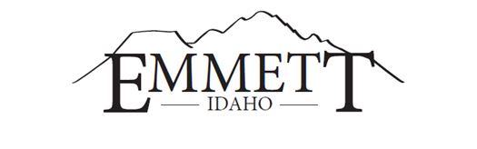
MAYOR:  Gordon W. Petrie, Presiding  CITY ATTORNEY:  Jake Sweeten  CITY CLERK:  Lyleen Jerome | EMMETT CITY COUNCIL  Live Stream  www.cityofemmett.org/meeting  SPECIAL COUNCIL MEETING  March 29, 2022  5:30 P.M. | COUNCILORS:  Steve Nebeker, President  Thomas Butler  Jody Harris  Eltona Henderson  Gary Resinkin  Denise Sorenson

AGENDA

1. Call to Order

2. Fiscal Year 20-21 Audit Review – Jordan Zwygart, Certified Public Accountant

~ACTION ITEMS~
3. Approve 20-21 Fiscal Year Audit

4. Approve payment to Zwygart John & Associates CPA, PLLC in the amount of $9,600.00

5. Adjourn

This institution is an equal opportunity provider. Any person needing special accommodations to participate in the above-noticed meeting should contact City Hall prior to the meeting at 501 East Main Street, Emmett, Idaho

